
Course Submission Cover Sheet Module:
CS5053 Cloud Computing and the Internet of Things
Assignment no: 001
Weighting: 50% of module mark
Deadline: 9th (Monday) of December 2024, 3pm
Module Leader: Dr Viktor Sowinski-Mydlarz Student ID: 23032697

PLAGIARISM
You are reminded that there exist regulations concerning plagiarism. Extracts from these regulations are printed below. Please sign below to say that you have read and understand these extracts:

(Signature:) Date:

This header sheet should be attached to the work you submit. No work will be accepted without it.
Extracts from University Regulations on
Cheating, Plagiarism and Collusion
Section 2.3: "The following broad types of offence can be identified and are provided as indicative examples …..
- Cheating: including taking unauthorised material into an examination; consulting unauthorised material outside the examination hall during the examination; obtaining an unseen examination paper in advance of the examination; copying from another examinee; using an unauthorised calculator during the examination or storing unauthorised material in the memory of a programmable calculator which is taken into the examination; copying coursework.
- Falsifying data in experimental results.
- Personation, where a substitute takes an examination or test on behalf of the candidate. Both candidate and substitute may be guilty of an offence under these Regulations.
- Bribery or attempted bribery of a person thought to have some influence on the candidate's assessment.
- Collusion to present joint work as the work solely of one individual.
- Plagiarism, where the work or ideas of another are presented as the candidate's own.
- Other conduct calculated to secure an advantage on assessment.
- Assisting in any of the above.
Some notes on what this means for students:
Copying another student's work is an offence, whether from a copy on paper or from a computer file, and in whatever form the intellectual property being copied takes, including text, mathematical notation and computer programs. Taking extracts from published sources without attribution is an offence. To quote ideas, sometimes using extracts, is generally to be encouraged. Quoting ideas is achieved by stating an author's argument and attributing it, perhaps by quoting, immediately in the text, his or her name and year of publication, e.g. " e = mc2 (Einstein 1905)". A references section at the end of your work should then list all such references in alphabetical order of authors' surnames. (There are variations on this referencing system which your tutors may prefer you to use.) If you wish to quote a paragraph or so from published work then indent the quotation on both left and right margins, using an italic font where practicable, and introduce the quotation with an attribution.

Contents
Components and Their Functions 3
Router 3
Switch 3
Home Gateway 3
Registration Server 3
Desktop PC, Laptop, Smartphone, and Tablet 3
IoT Devices 3
Microcontrollers (MCU) 4
Connections Between Devices 4
Wired Connections (Fast Ethernet) 4
Wireless Connections 4
IoT Custom Cable Connections 4
Development Process 4
Modelling and Setup: 4
Device Configuration: 4
IoT Device Setup: 5
Scenario Implementation: 5
Using Screenshots in the Report 5
Conclusion 7

Components and Their Functions

Router
Function: Acts as the central device connecting the smart home to the internet. It facilitates communication between external networks and internal devices.
Connection: Connected to the Switch via Fast Ethernet.

Switch
Function: Provides a local area network (LAN) that allows devices to communicate. Serves as the intermediary between the router, the registration server, and other wired devices.
Connection:
Connected to the Router for external communication.
Connected to the Home Gateway and Registration Server via Fast Ethernet
.

Home Gateway
Function: Acts as the central point for IoT devices, enabling them to communicate wirelessly and via wired connections.
Connection:
Linked to the Switch via Fast Ethernet.
Provides wireless connectivity to IoT devices such as the Laptop, Smartphone, Webcam, and others.

Registration Server
Function: Stores and monitors data from smart devices, such as power consumption, motion detection logs, and water level monitoring.
Connection: Connected to the Switch via Fast Ethernet.

Desktop PC, Laptop, Smartphone, and Tablet
Function: Used to control and monitor devices via the IoT monitor.
Connection:
Desktop PC: Connected to the Switch via Fast Ethernet.
Laptop, Smartphone, and Tablet: Connected wirelessly to the Home Gateway.

IoT Devices
Webcam: Used for remote monitoring; activated by motion detection.
Home Speaker: Provides audio alerts or notifications.
Light, Coffee Maker, Ceiling Fan: Smart appliances controlled via the IoT monitor.
Temperature Sensor: Monitors room temperature and sends readings to the thermostat.
Smoke Detector and CO/CO2 Detector: Monitors for fire and gas hazards, triggering alarms and sprinklers.
Solar Panel and Battery: Simulate renewable energy generation and storage.
Lawn Sprinkler: Monitors water usage and can be controlled remotely.
Garage Door and Front Door: Automated for security and convenience.
Motion Sensor and Alarm: Detects movement and triggers alerts.
Ceiling Sprinkler: Activated during a fire.

Microcontrollers (MCU)
Function: Connect sensors (e.g., Smoke Detector, Temperature Sensor) and actuators (e.g., Alarm, Siren, LCD) that require specific ports not available on the Home Gateway.
Connection: Devices are linked to GPIO or Analog ports on MCUs using IoT custom cables.

Connections Between Devices

Wired Connections (Fast Ethernet)
Router ↔ Switch
Switch ↔ Home Gateway
Switch ↔ Registration Server
Switch ↔ Desktop PC

Wireless Connections
Home Gateway ↔ Laptop, Smartphone, Tablet
Home Gateway ↔ IoT Appliances (Webcam, Speaker, Light, Coffee Maker, etc.)

IoT Custom Cable Connections
MCUs ↔ Smoke Detector, Motion Sensor, Temperature Sensor
MCUs ↔ Alarm, Siren, Ceiling Sprinkler, LCD

Development Process

Modelling and Setup:
Dragged all components (router, switch, home gateway, registration server, and IoT devices) onto the Cisco Packet Tracer workspace.
Established Fast Ethernet connections using Ethernet cables for wired devices.
Configured wireless settings on the Home Gateway to allow IoT devices and portable devices to connect.

Device Configuration:
Assigned IP addresses to the router, switch, and home gateway.
Configured the registration server to log data from IoT devices, such as motion detection and power consumption.

IoT Device Setup:
Assigned each IoT device to the Home Gateway for wireless communication.
Linked sensors and actuators to the MCU boards using IoT custom cables, ensuring proper connections to GPIO or Analog ports.

Scenario Implementation:
Appliance Control: Verified that appliances like lights and coffee makers could be toggled remotely using the IoT monitor.

Monitoring and Alerts: Configured devices like the Motion Sensor, Smoke Detector, and CO/CO2 Detector to trigger appropriate actions (e.g., Webcam activation, Alarm).

Power Flow Simulation: Linked the Solar Panel, Power Meter, and Battery to demonstrate energy generation and storage.

Using Screenshots in the Report
Device Setup:

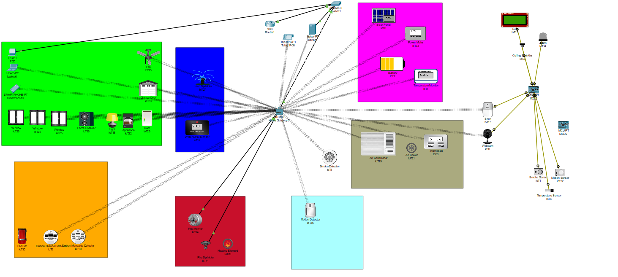

Screenshot of the workspace showing the layout of devices and connections.
Key components (Router, Switch, Home Gateway, etc.).

Appliance Control:

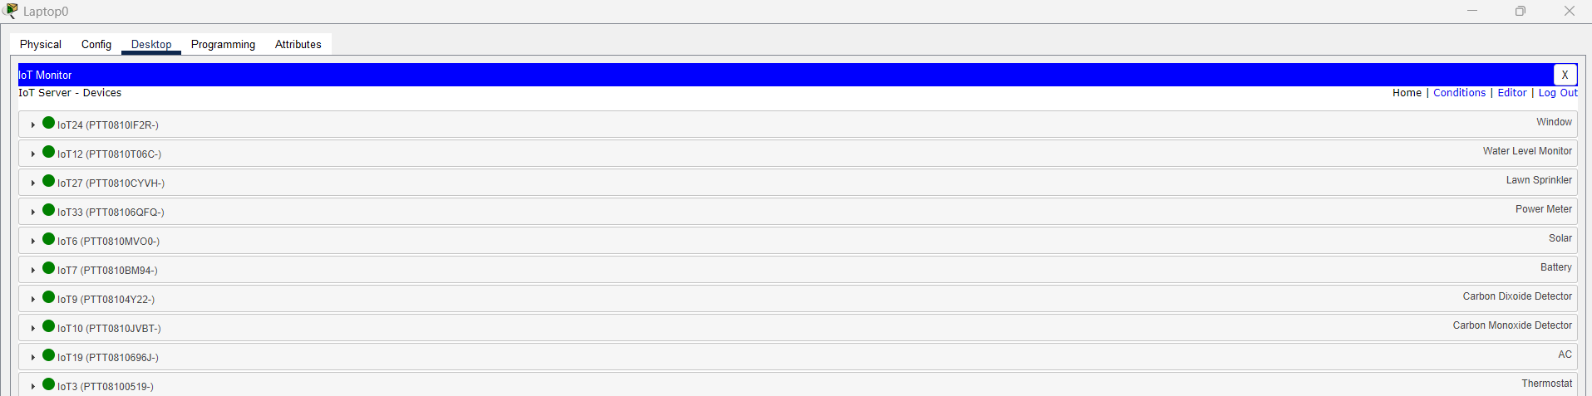

Screenshot of the IoT monitor interface showing remote toggling of appliances.

Scenario Demonstrations:

Fire Sprinkler Activation:

The Fire Sprinkler Activation scenario demonstrates the integration of the Smoke Detector with the Ceiling Sprinkler system to respond to a simulated fire. The Smoke Detector is connected to the Microcontroller Unit (MCU) and configured to send a signal to the Ceiling Sprinkler when smoke is detected.

Steps:
The Smoke Detector was connected to the MCU using a GPIO port.
The Ceiling Sprinkler was configured to activate when it received a signal from the Smoke Detector.
A fire source was placed near the Smoke Detector in the simulation to emulate smoke presence.

Outcome:
The Ceiling Sprinkler was activated automatically upon detecting smoke, demonstrating the system's effectiveness in responding to fire hazards. The simulation validates the real-time response of the Smoke Detector and Sprinkler system in enhancing safety in a smart home.

Motion Detection:

This scenario illustrates the use of a Motion Sensor to enhance security by activating a Webcam when motion is detected. The Motion Sensor and Webcam are wirelessly connected to the Home Gateway and linked through the IoT Monitor.

Steps:
The Motion Sensor was configured to detect movement within its range.
The Webcam was programmed to respond to the Motion Sensor’s signal by starting video recording.
Movement was simulated near the Motion Sensor to test the setup.

Outcome:
When motion was detected, the Webcam activated instantly, recording the area under surveillance. This scenario highlights the utility of motion-activated surveillance in home security applications.

Power Monitoring:

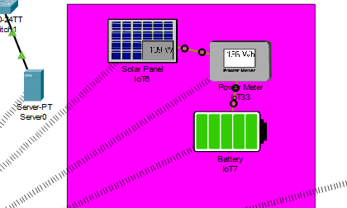

The Power Monitoring scenario demonstrates energy flow from a Solar Panel to a Battery via a Power Meter. This setup simulates a renewable energy system for a smart home and monitors energy production and storage.

Steps:
The Solar Panel was connected to the Power Meter, which was linked to the Battery.
The Registration Server was configured to monitor energy flow and display data in real time.
Power generation was simulated, showing the Solar Panel charging the Battery through the Power Meter.

Outcome:
The Registration Server successfully logged energy metrics, including the power generated by the Solar Panel and stored in the Battery. This simulation underscores the role of IoT in enabling efficient energy management in smart homes.

Conclusion
This smart home simulation project provided a comprehensive learning experience in designing and implementing an interconnected IoT environment. By integrating various devices, sensors, and actuators, I gained a deeper understanding of how smart technologies function collaboratively to enhance automation, efficiency, and convenience in everyday life.
The project successfully demonstrated the potential of IoT systems in creating a seamless smart home experience. Each task was designed to highlight a specific functionality, from controlling appliances remotely to monitoring energy usage and activating safety systems. The simulations illustrated practical scenarios, such as fire response and motion-activated surveillance, which are critical applications of IoT in real-world settings.
On a broader scale, the integration of smart technologies into homes and cities offers significant benefits. Smart devices can optimize energy use, reduce waste, enhance security, and improve overall quality of life by providing greater convenience and automation. For example, energy-efficient appliances can help reduce utility costs, while smart surveillance systems offer heightened security for households. These advancements contribute to environmental sustainability and the streamlining of daily tasks, fostering a more connected, efficient, and comfortable living environment.
However, the societal impact of smart technology also presents challenges. Privacy concerns are a significant issue, as increased connectivity can lead to the collection of sensitive personal data, which may be vulnerable to cyberattacks or misuse. Additionally, the reliance on smart devices raises questions about data ownership, security, and the potential for surveillance. There is also the risk of technological dependency, where people may become too reliant on automated systems, leading to a loss of traditional skills and social interactions. Furthermore, the environmental cost of manufacturing, operating, and disposing of smart devices raises concerns about sustainability.
Some challenges were encountered during the process, including configuring device compatibility, establishing reliable connections, and troubleshooting errors in sensor-triggered tasks. Overcoming these issues enhanced my problem-solving skills and gave me valuable insights into the complexities of IoT systems.

Reflection on Learning
This assignment taught me the importance of precise device configuration and the role of protocols in ensuring interoperability among IoT devices. I also developed skills in network configuration, automation logic, and data monitoring, which are essential in IoT development. Additionally, working with Cisco Packet Tracer offered a hands-on approach to simulate real-world IoT implementations, bridging the gap between theoretical knowledge and practical application.

Evaluation of the Work
The project successfully demonstrated the potential of IoT systems in creating a seamless smart home experience. Each task was designed to highlight a specific functionality, from controlling appliances remotely to monitoring energy usage and activating safety systems. The simulations illustrated practical scenarios, such as fire response and motion-activated surveillance, which are critical applications of IoT in real-world settings.
Some challenges were encountered during the process, including configuring device compatibility, establishing reliable connections, and troubleshooting errors in sensor-triggered tasks. Overcoming these issues enhanced my problem-solving skills and gave me valuable insights into the complexities of IoT systems.

